**4. Configure the DocumentDB Performance Insights - Check the Top Querie, Top Host, Top Database, Top Application and metrics**

Step 1:

Creating DocDB instance:

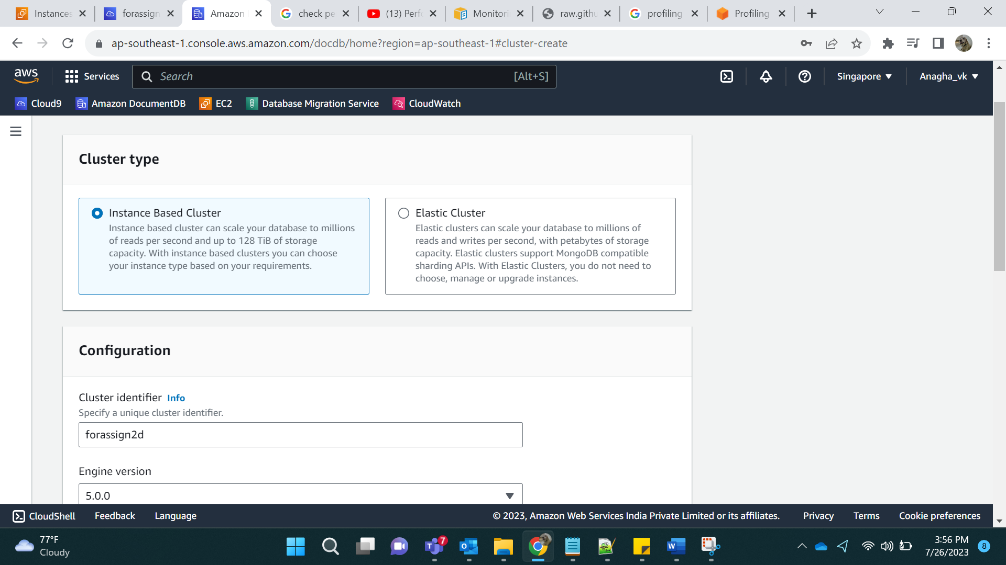

No of instance 1

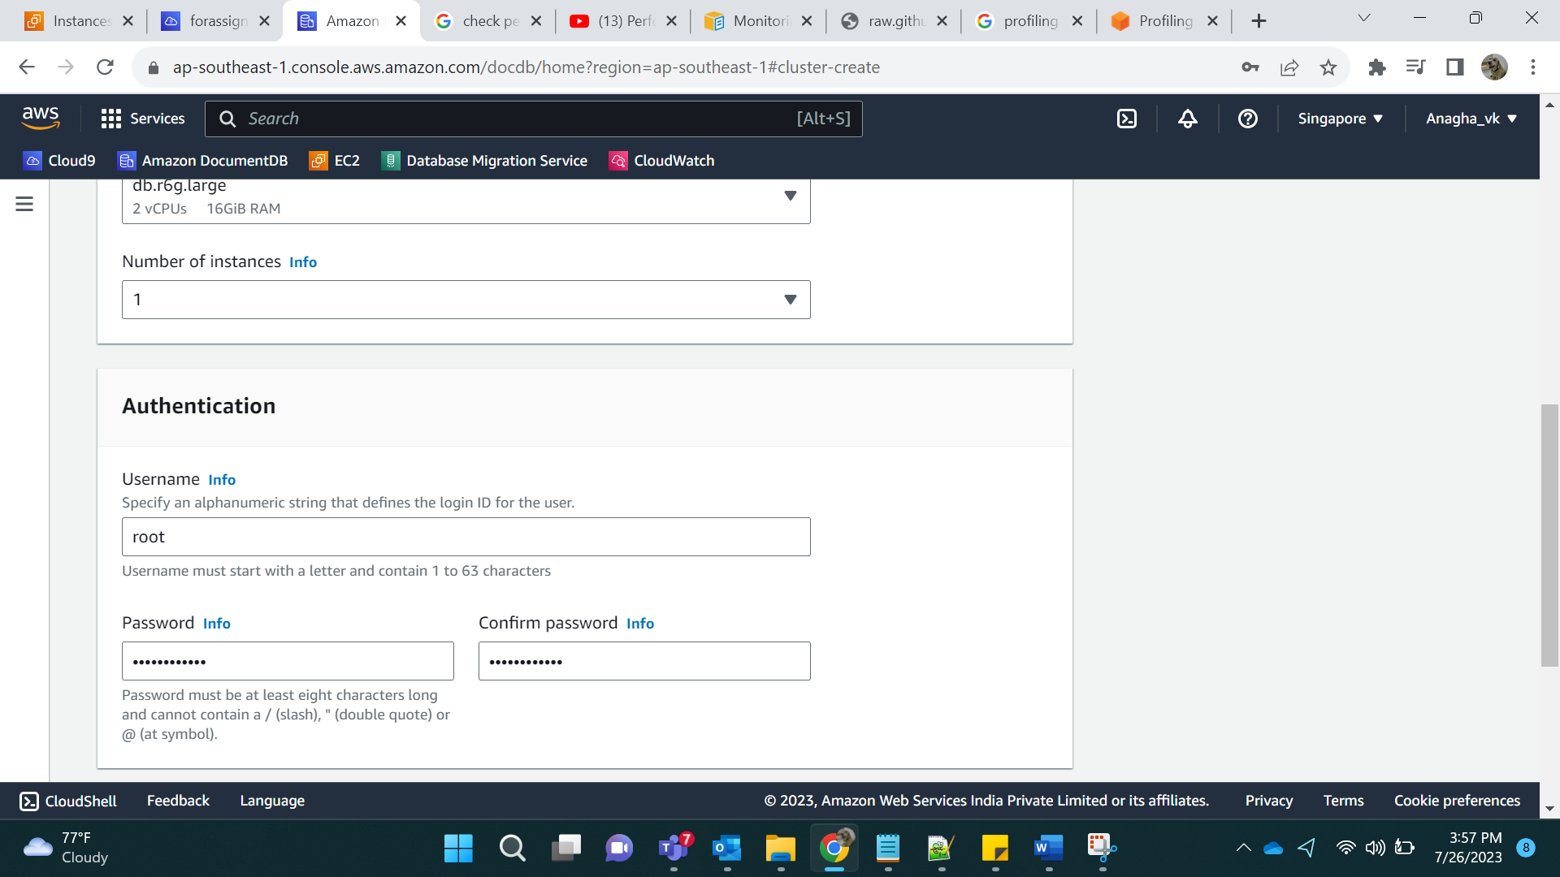

In advance setting, enable performance insights:

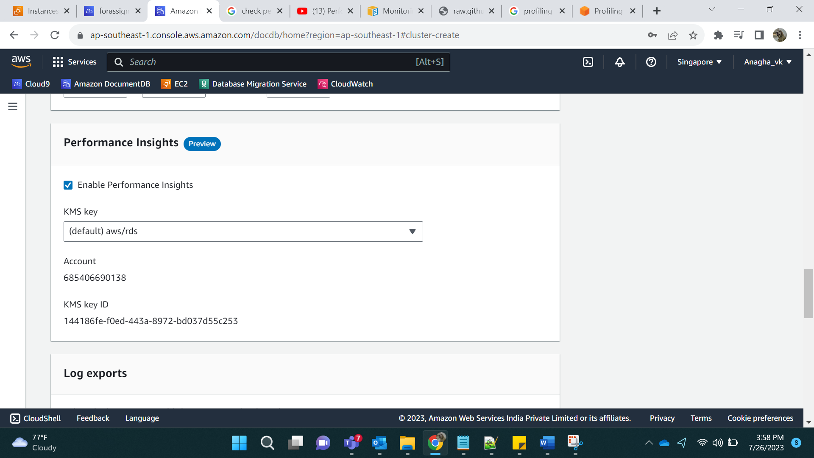

Go to Cloud9 which had mongodbinstall and run few commands:

This is done so that we can see processing in docDB.

wget <https://truststore.pki.rds.amazonaws.com/global/global-bundle.pem>

mongo --ssl --host forassign2d.cluster-cia4bvgv8e4r.ap-southeast-1.docdb.amazonaws.com:27017 --sslCAFile global-bundle.pem --username root --password administrator

exit

mongoimport --ssl --host forassign2d.cluster-cia4bvgv8e4r.ap-southeast-1.docdb.amazonaws.com:27017 --sslCAFile global-bundle.pem --username root --password adminstrator --collection=daily_cases --db=testdb --file=cases.json

connect to mongo:

db.daily_cases.find({"Cases": 1068})

db.daily_cases.aggregate([{ $match: { Cases: { $gte: 100, $lt: 1000 } }}, { $group: { _id: null, count: { $sum: 1 } } } ]);

exit

Go to document Db performance insights and select the cluster we need to observe.

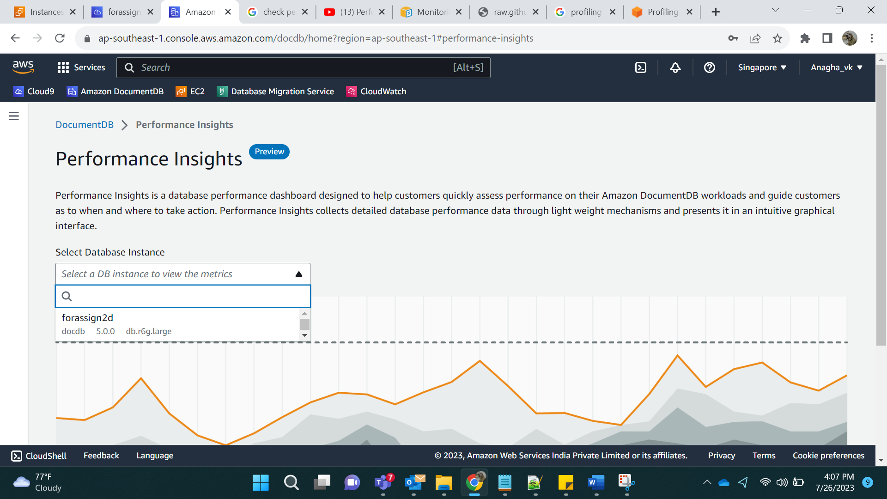

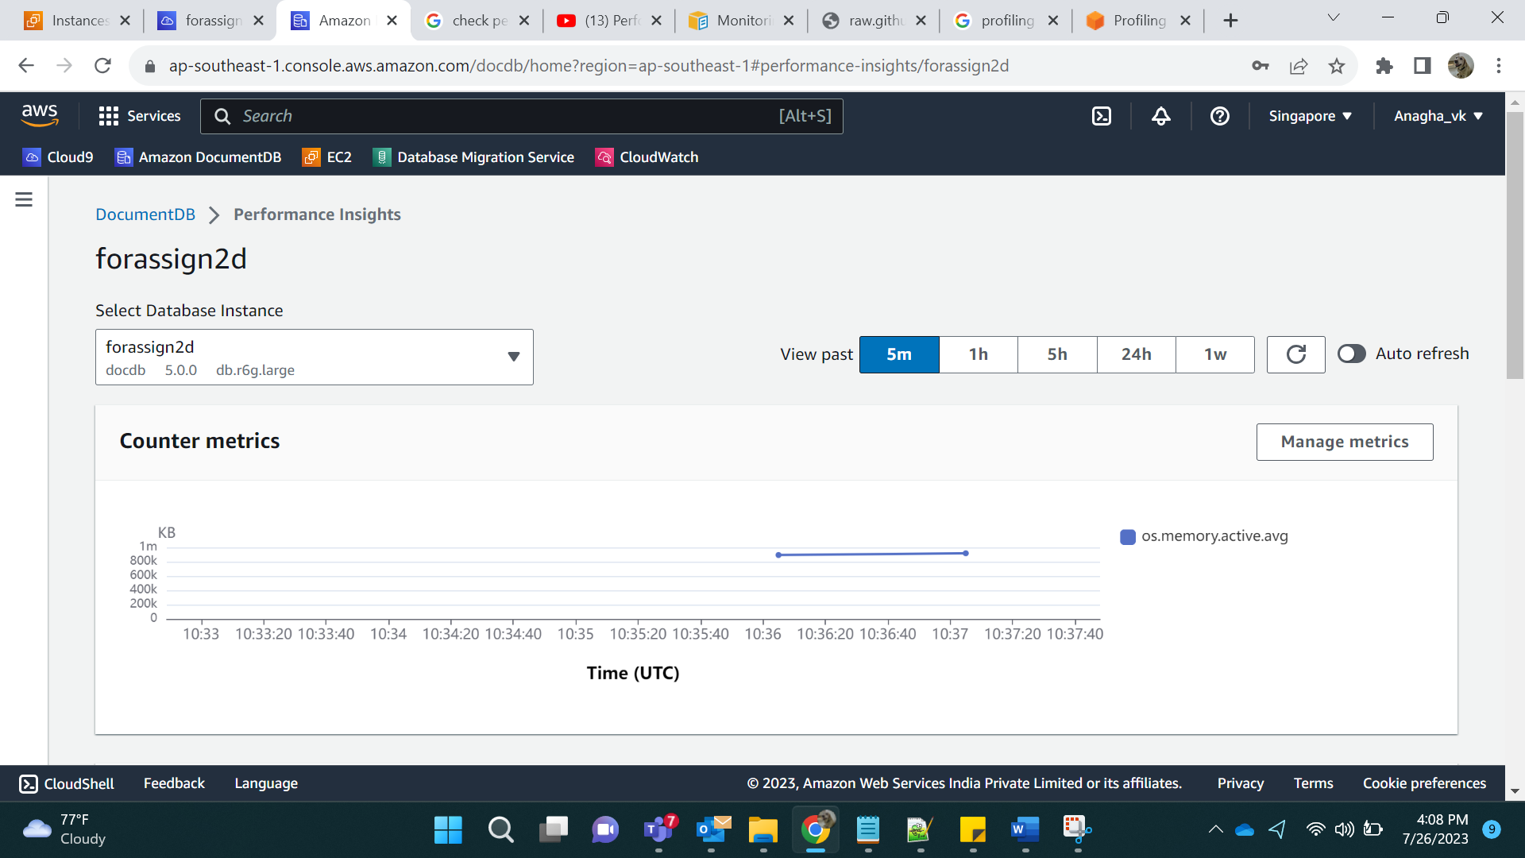

Showing MaxCPU:

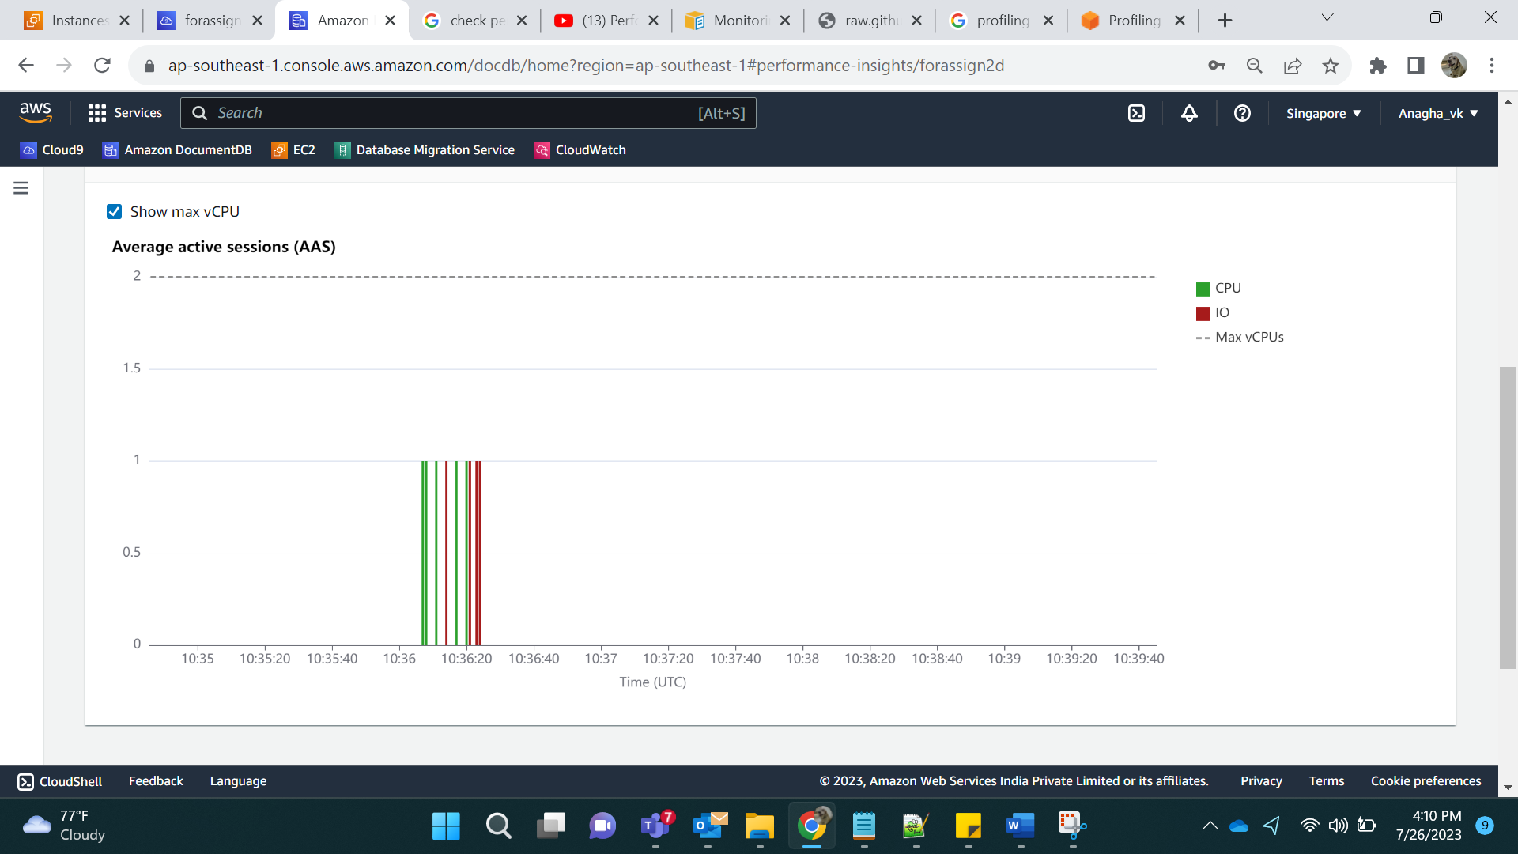

Top Waits:

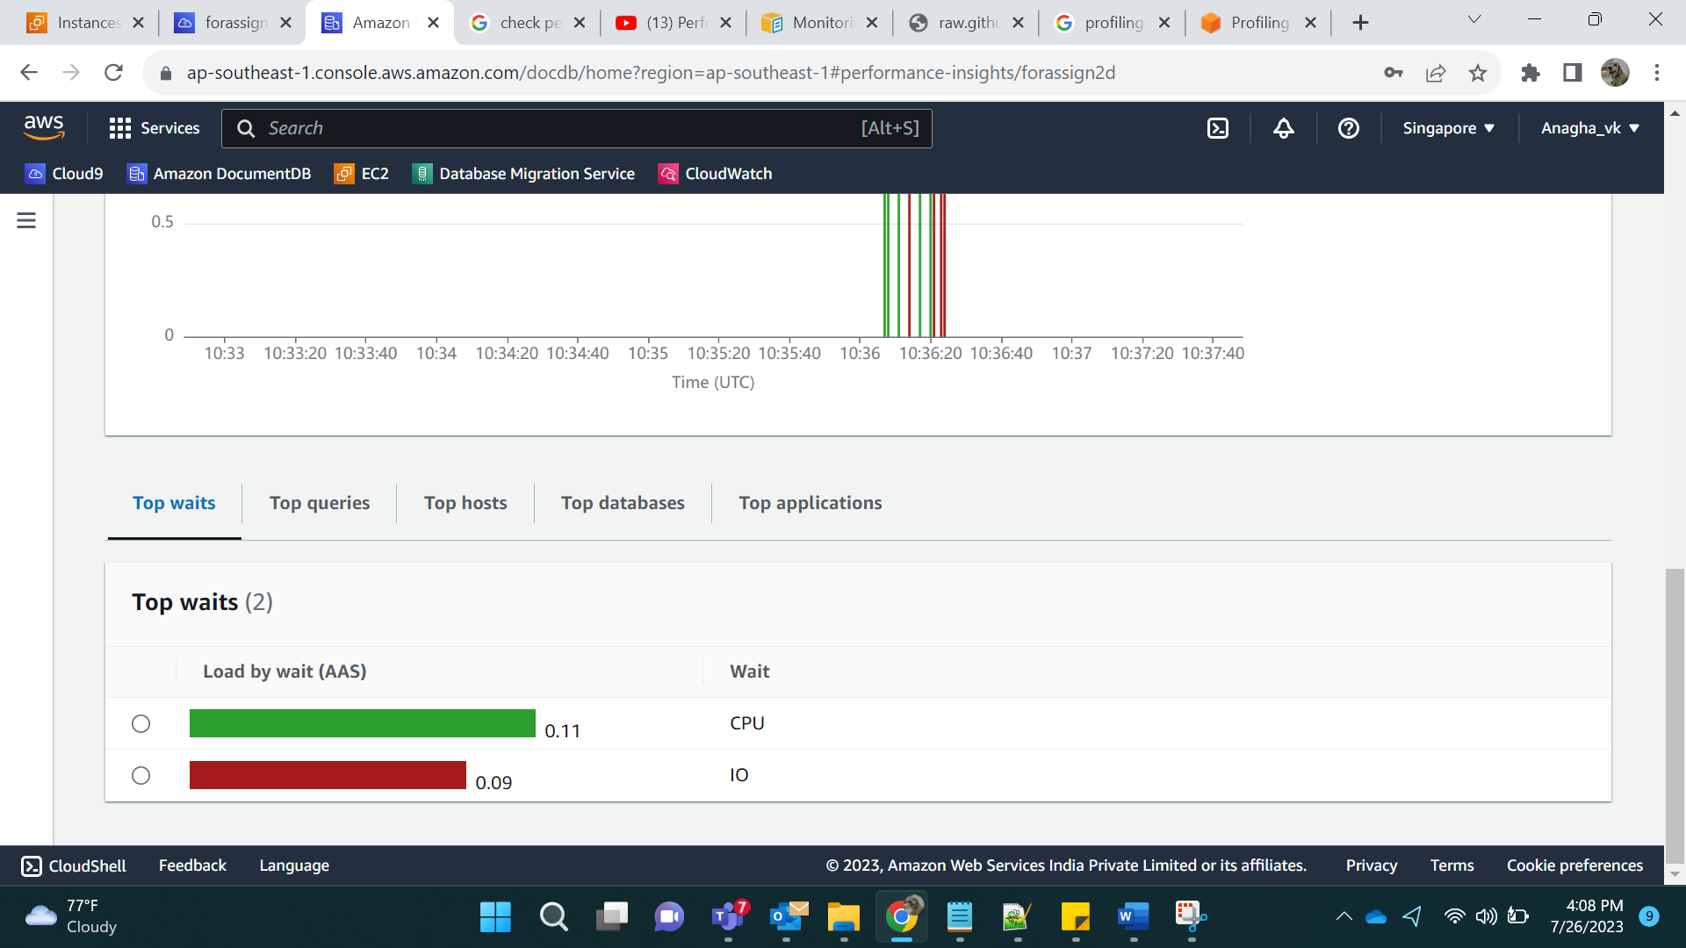

Top Queries:

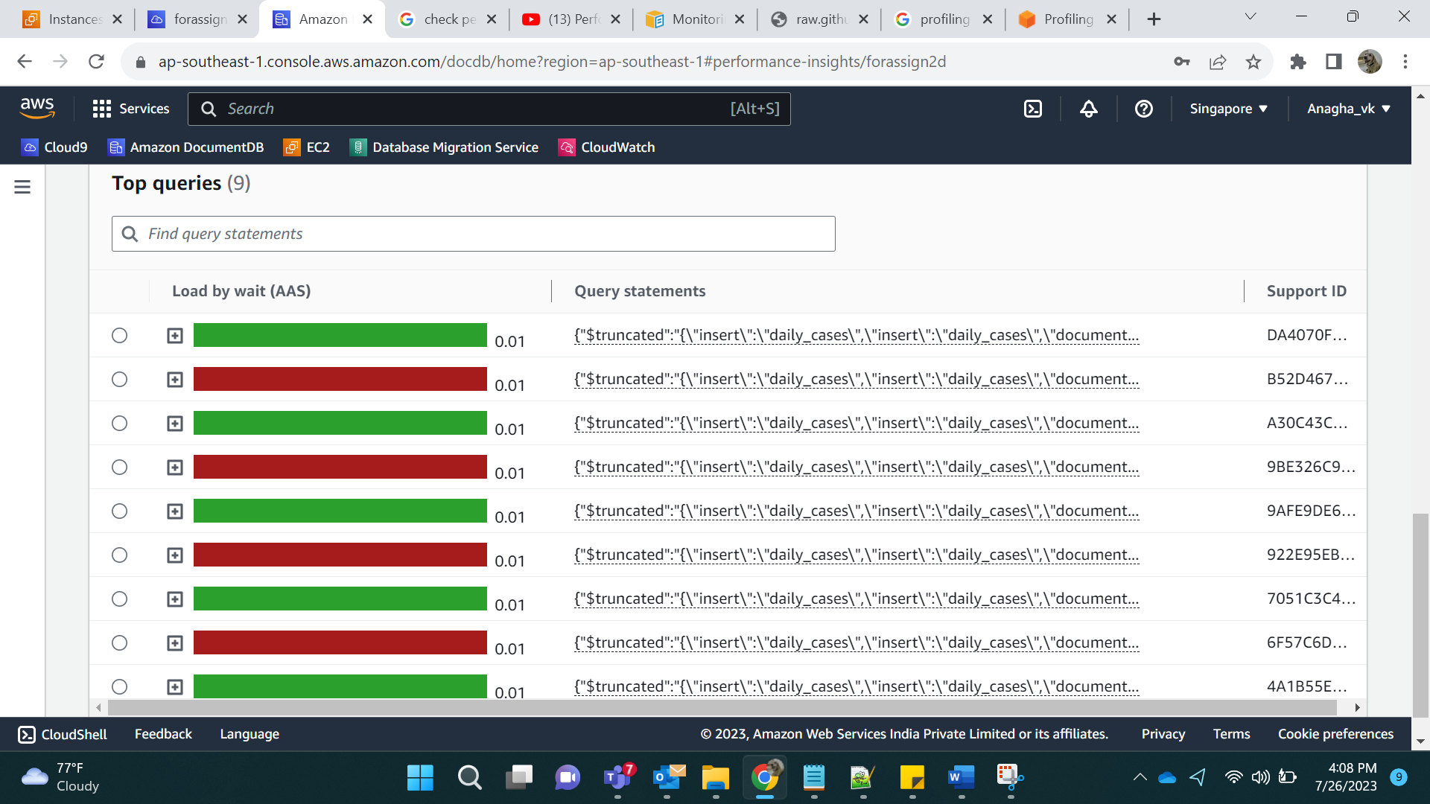

Top Hosts:

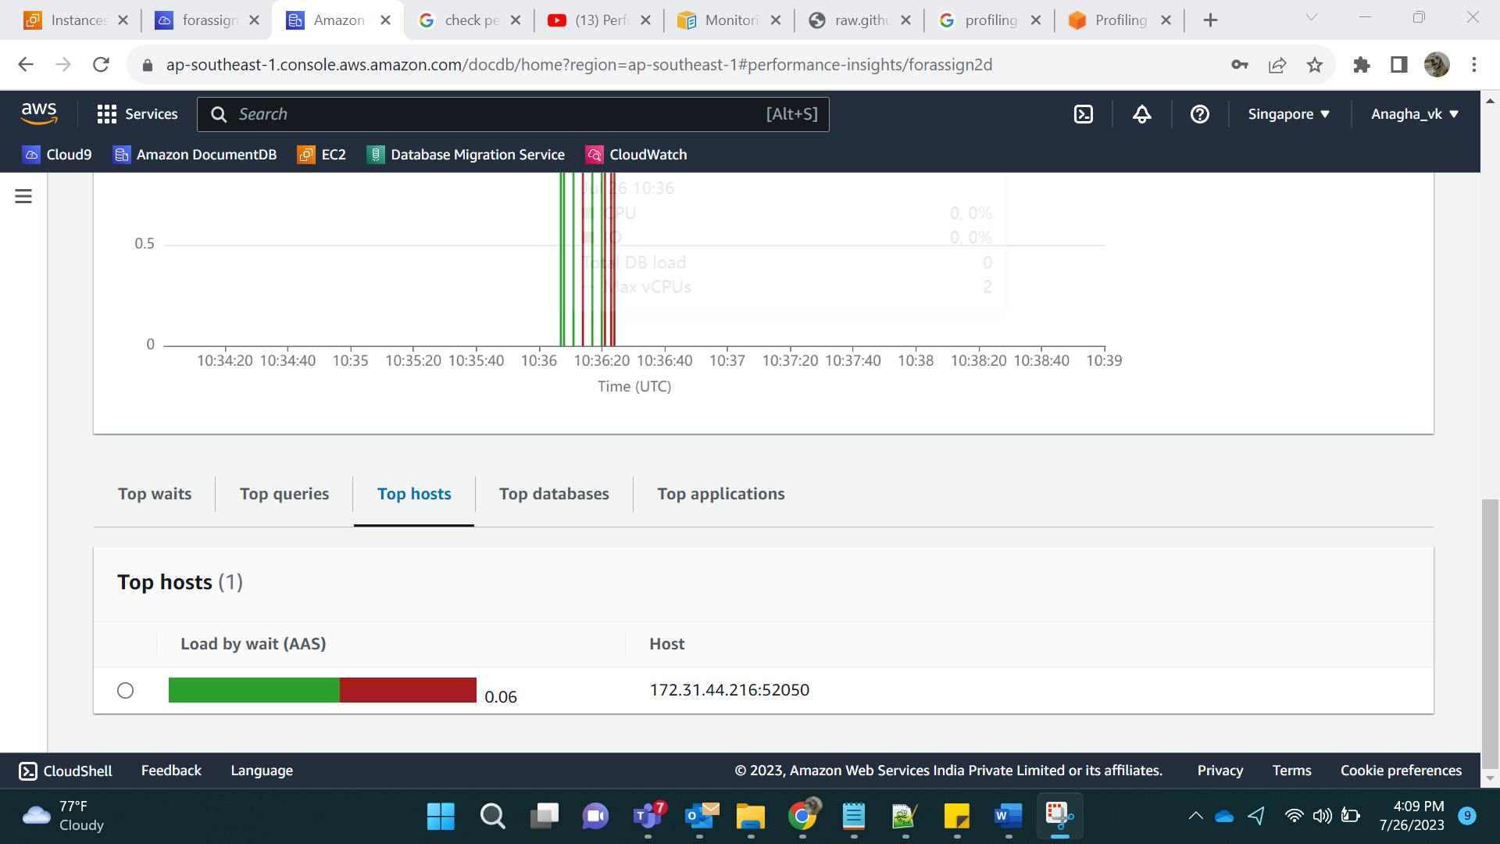

Top Database:

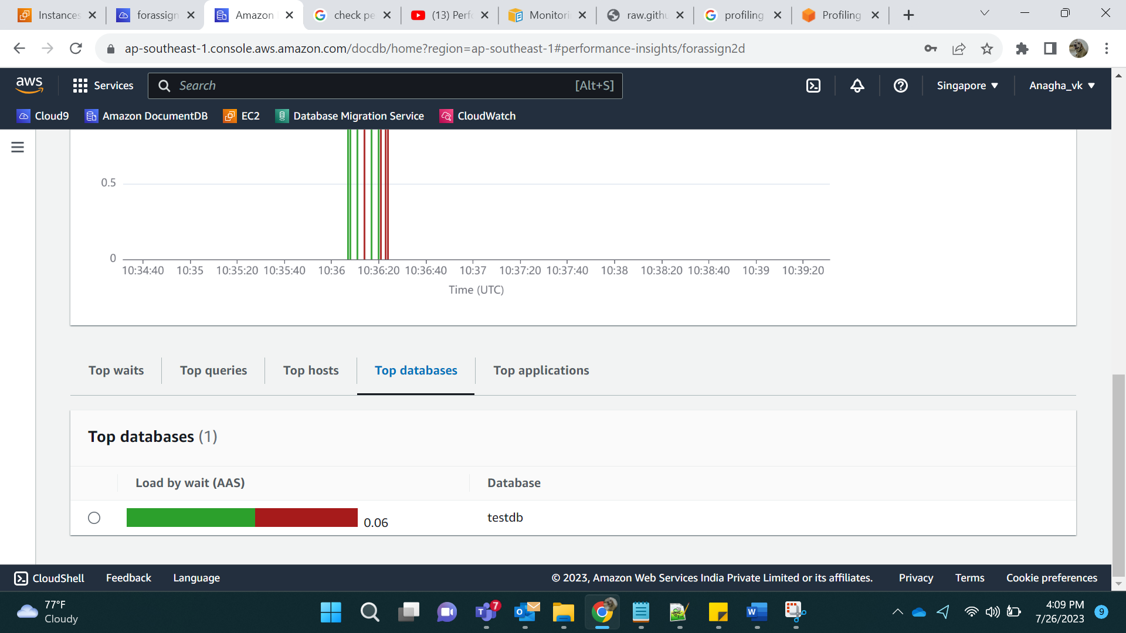

Top Applications:

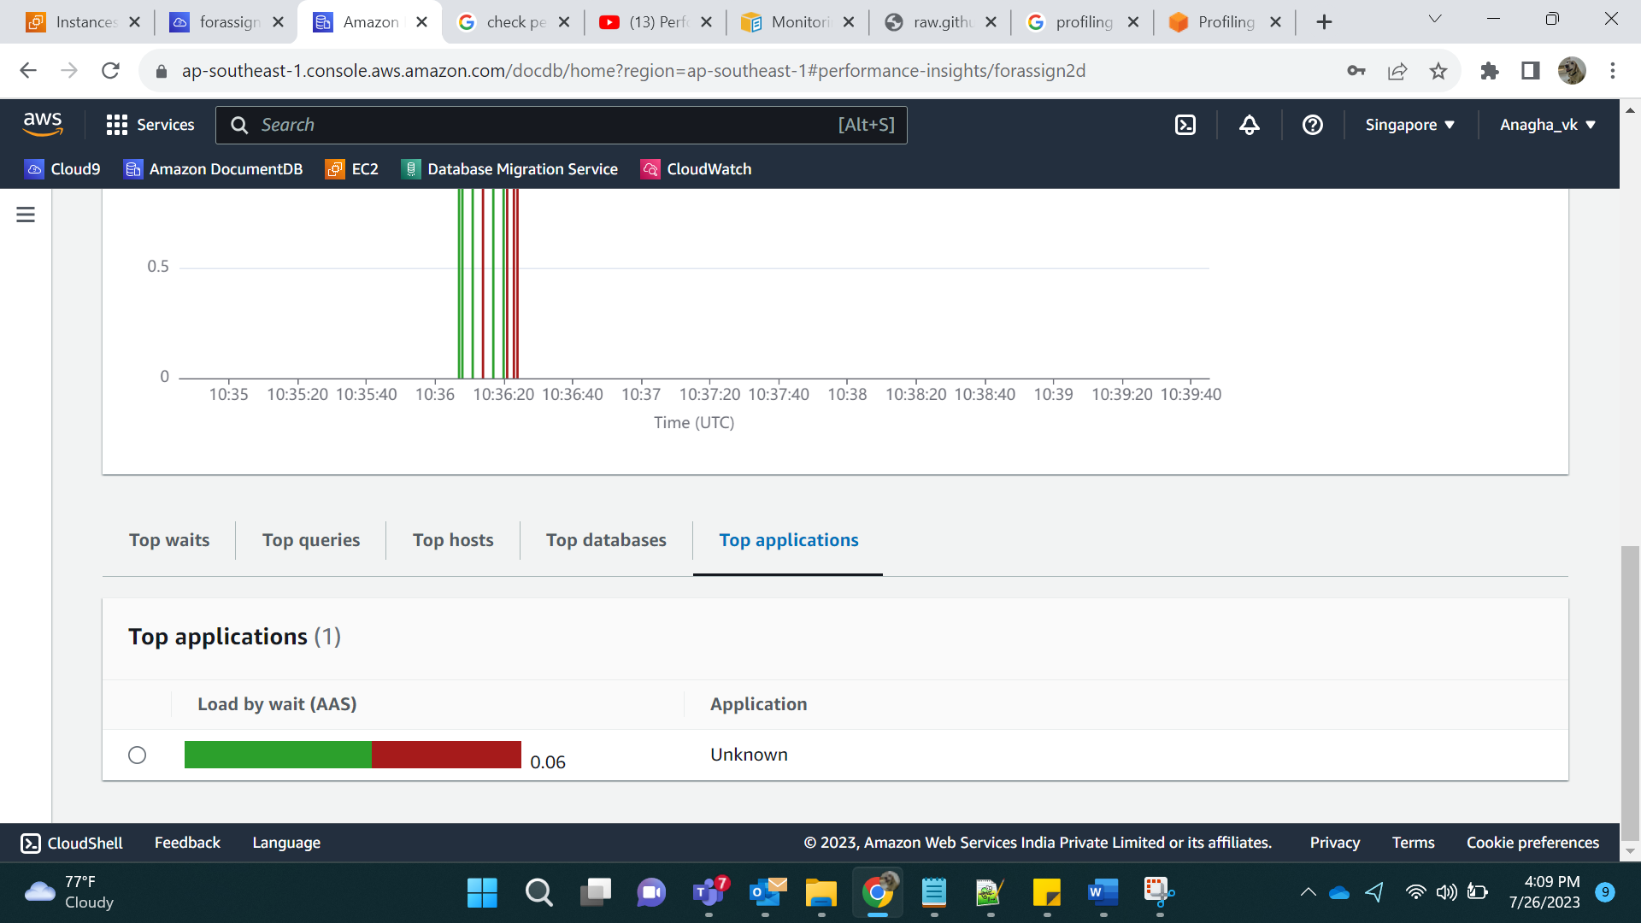

In Metrics, I selected active metric:

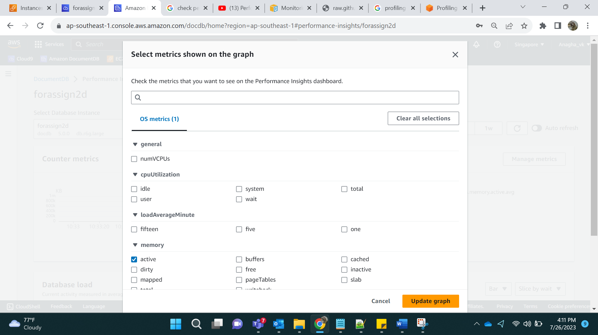

Output:

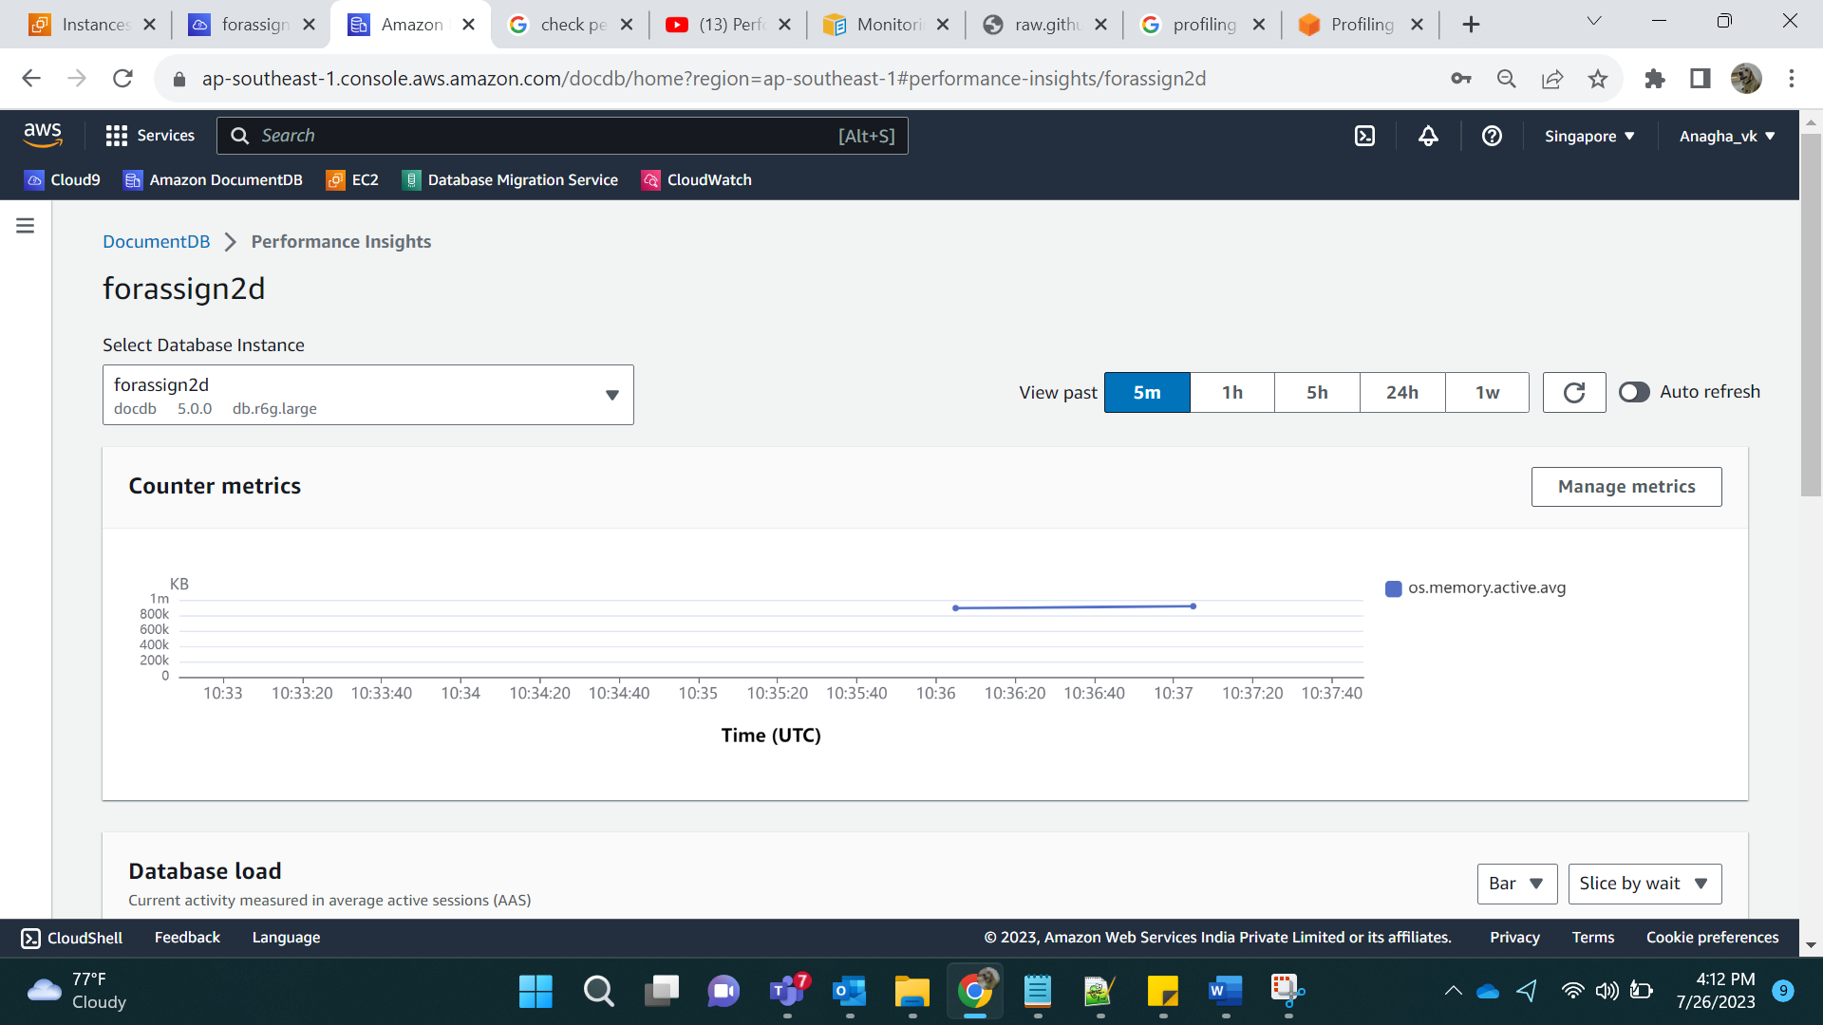

CPU related metrics:

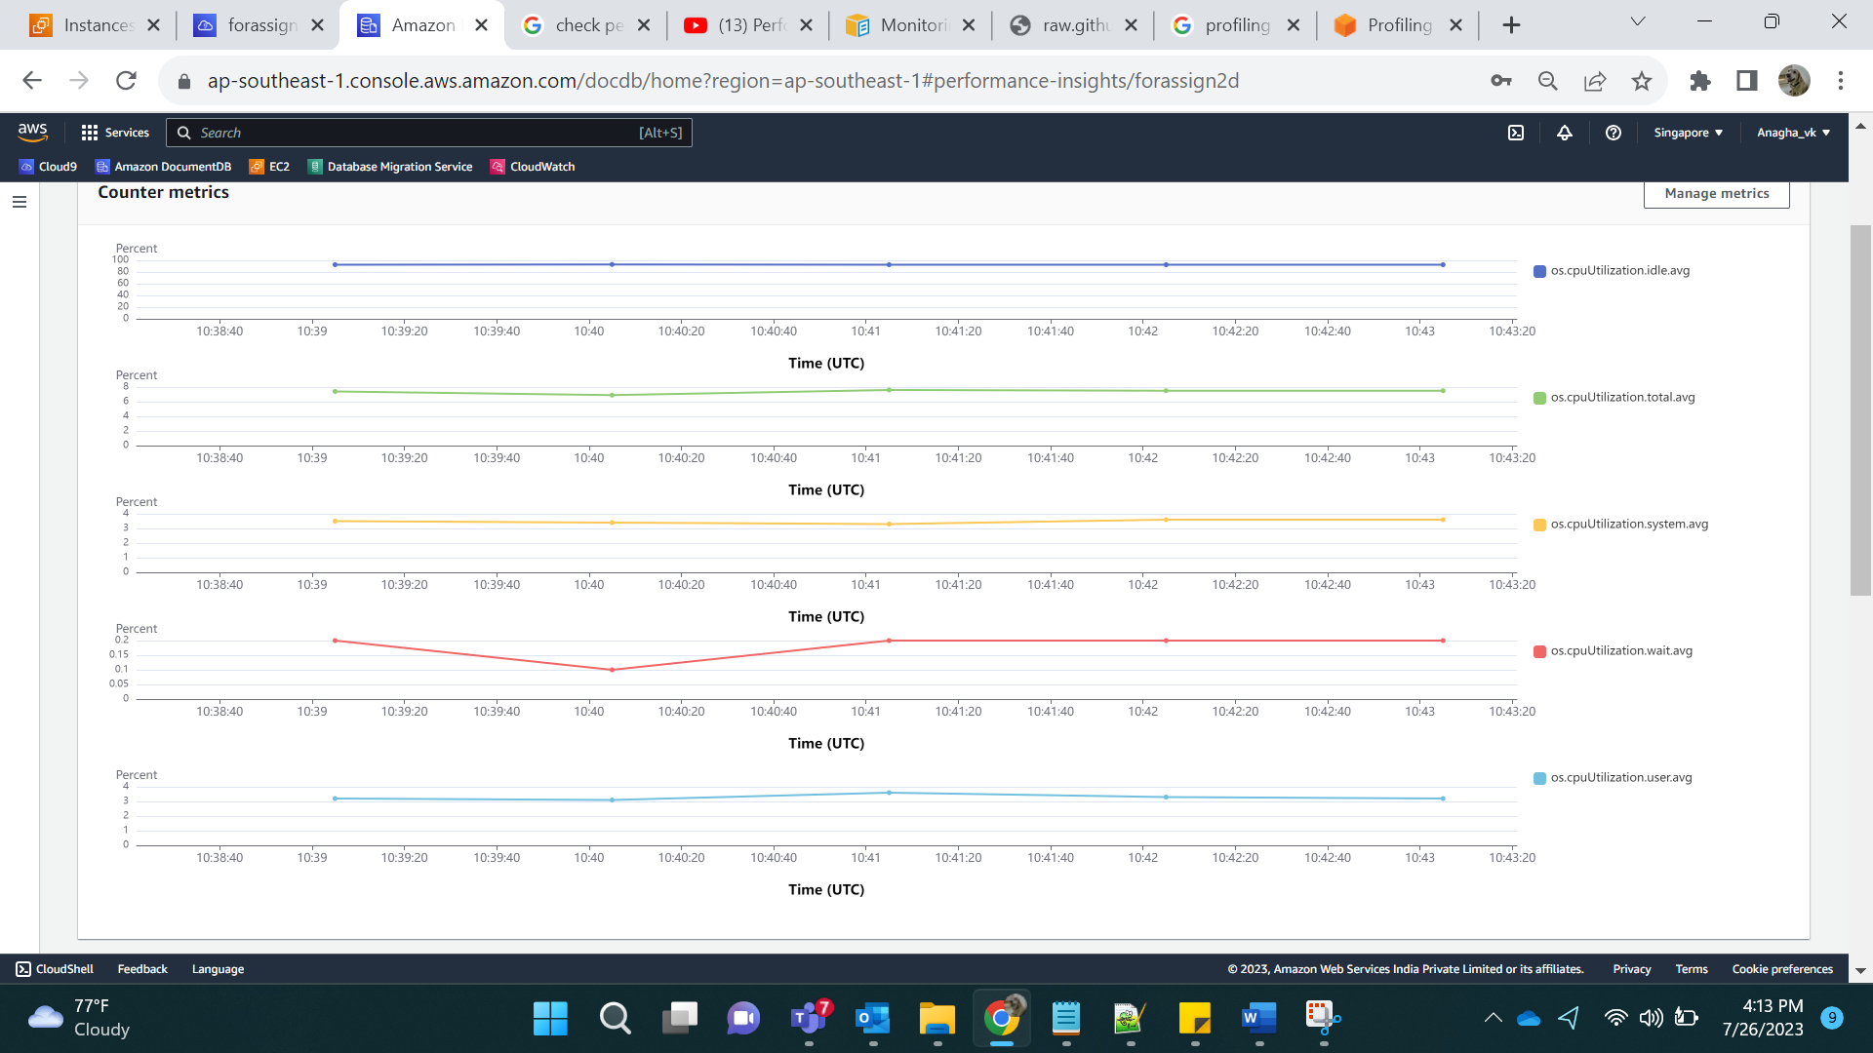

Load Average Minute:

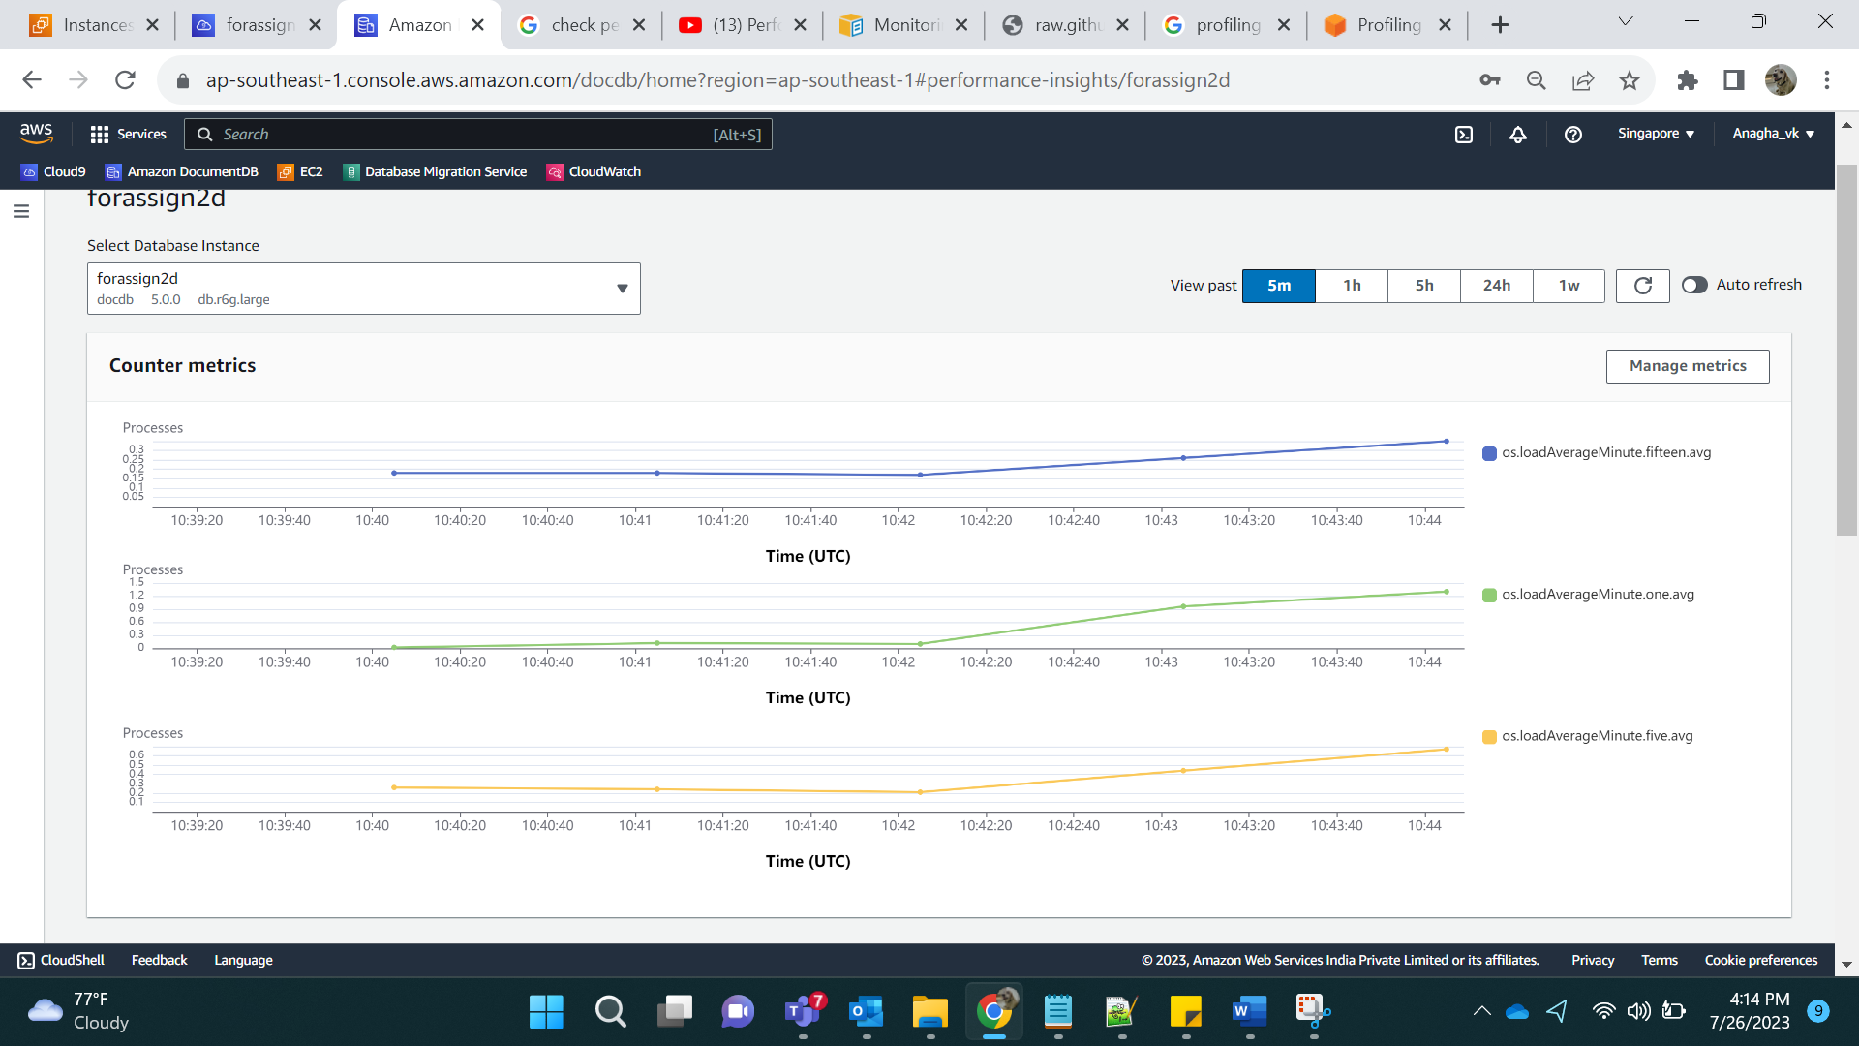

Network related metrics:

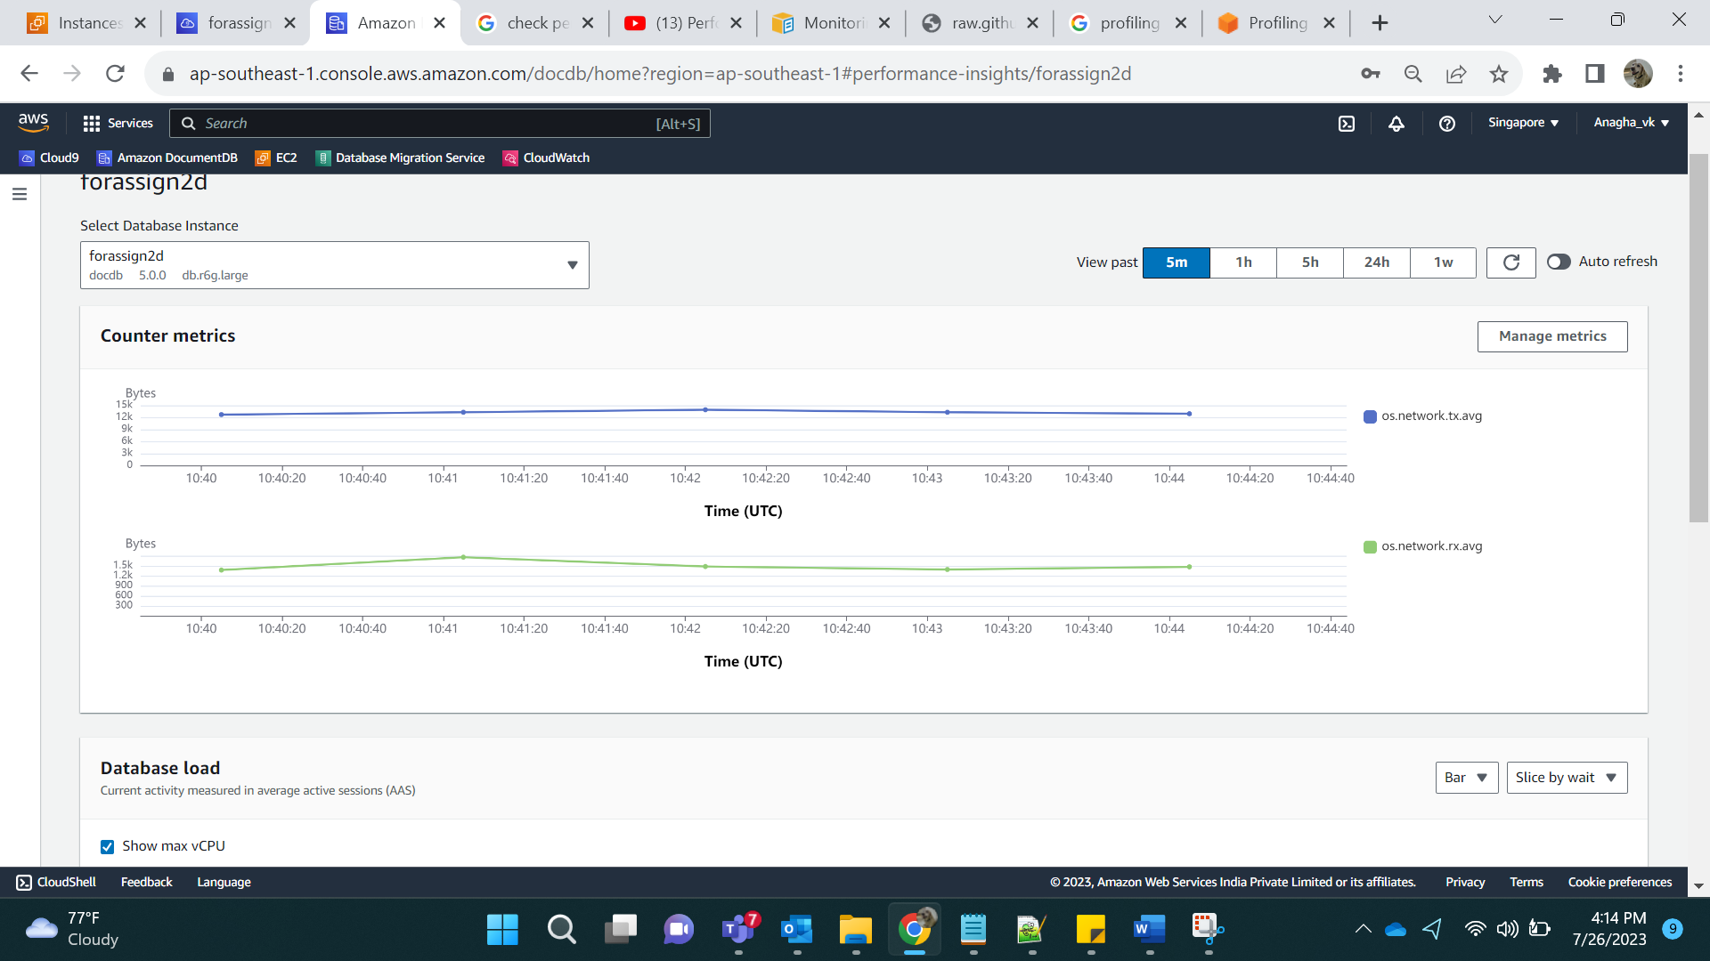

Memory Related Metrics:

